
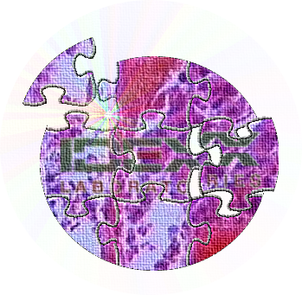
IDEXX Laboratories Ltd
Grange House, Sandbeck Way
Wetherby
West Yorkshire LS22 7DN
Tel: UK 02037887508
Ireland 00353015621211
Fax: 01937 544001
e-mail: customersupportuk@idexx.com

PROSTATIC MASSAGE

Indications

Cytological evaluation of cells/fluid from the prostate is a useful diagnostic aid in the investigation of prostatic disease although the sensitivity of this technique is limited and inconclusive samples are possible. Whenever possible, an ultrasound-guided fine needle biopsy is preferred. The guided aspirate technique samples the prostatic parenchyma directly and it is less affected by urine-induced cellular degeneration.
The clinical signs associated with prostatic disease often relate to prostatomegaly and include difficulty in defecation and/or micturation. There may also be evidence of blood in the urine or blood at the tip of the penis.
On rectal examination the gland may be symmetrically enlarged (maintaining a bi-lobed structure) or there may be unilateral or focal irregularities. These features are of clinical significance and should be noted in the history.

Prostatic Massage

In those patients in whom it is possible to palpate the prostate gland per rectum the following technique facilitates collection of cellular material.

Equipment
- Urinary catheter of sufficient length the reach the base of the prostate gland.
- 10ml syringe.
- Glass slides.
- Sterile saline.
- EDTA and plain tubes.
- 1 operator and 1 assistant.

Method 1 - Prostatic Massage
- The urinary catheter is passed to the level of the base of the prostate gland. The position of the catheter can be confirmed by rectal palpation.
- The 10ml syringe is attached to the end of the catheter and negative pressure applied by the assistant while the operator gently massages the prostate gland per rectum.
- Only a small amount of fluid /cells will be drawn into the catheter.
- The negative pressure is released, the catheter withdrawn, and squash preparations made of the material collected at the tip of the catheter.
- It may be necessary to disconnect the syringe and flush air or saline through the catheter to dislodge the collected material.

Method 2 - Prostatic Wash
- This technique is used to collect additional material for cytological evaluation and microbiological studies.
- The technique is performed as for prostatic massage but a small amount of sterile saline is flushed into the prostatic urethra and retrieved during prostatic massage.

Sample Submission

- Several unstained glass slides prepared by wedge technique (see figure 1 below) should be submitted in a plastic slide transporter (available from the laboratory upon request). When the smears have been made they should be rapidly dried. The airstream from a hairdryer is suitable for this. Air (warm/cool but not hot) should be directed onto the back of the slide form a distance of 6-8 inches.
- Small (5 ml) boric acid urine containers are also available if bacteriology is required.
- To preserve the cellular morphology inclusion of an EDTA sample, promptly fixed with the addition of two drops of 10% buffered neutral formal saline (as supplied in our histopathology pots) per ml of fluid, and labelled accordingly is recommended. This will be processed separately and stained with a modified Papanicolaou stain, which greatly improves the diagnostic yield

