Collection of Bone Marrow Samples from Dogs and Cats
Introduction
Evaluation of a bone marrow aspirate and a bone marrow core biopsy may provide valuable information about the status of the bone marrow, its ability to respond to correct abnormalities in the peripheral blood and/or to determine if there is infection, myelofibrosis, necrosis, neoplasia or other abnormalities.
For optimal interpretation of the status of the bone marrow, a Full Blood Count and peripheral blood film should be submitted at the same time as the bone marrow aspirate. A bone marrow biopsy should be collected at the same time as the bone marrow aspirate. If instructed on the submission form, a bone marrow core biopsy may be held pending the results of the bone marrow aspirate and processed if additional histologic evaluation is considered to likely be useful based on the bone marrow aspirate findings.
Patient Restraint
Bone marrow collections are typically performed under general anaesthesia. In compliant animals it may be possible to obtain bone marrow samples with sedation and local anaesthesia.
Equipment
- Jamshidi Disposable Illinois sternal-iliac bone marrow needle (Vet Instrumentation, 62 Cemetery Road, Sheffield. Tel: 0845 1309596). An 18 gauge needle is usually adequate for medium to large dogs. A paediatric needle may be preferred for small dogs and cats.
- Petri dish.
- Microscope slides (frosted end preferred), labelled with patient name in pencil.
- Small disposable pipettes or capillary tubes.
- 2-3% EDTA/isotonic saline solution. This may be prepared as follows: A 2 ml EDTA vacutainer tube (lavender top) is filled with isotonic (0.9%) saline and mixed well. The 2 ml of the resulting EDTA solution is added to 5-8 ml of sterile isotonic saline in a serum tube (red top).
- 10 ml syringe
- Tissues or gauze sponge for wicking away blood during smear preparation
- At least 2 ml of 10% buffered formalin in histology submission pot.

Sample Collection
Bone marrow aspirate collection
- Animals may be standing or positioned in sternal or lateral recumbency, depending on the site of collection and collector preferences.
- Sites commonly used for collection include the iliac crest (medium to large dogs), trochanteric fossa (small dogs and cats) or proximal humerus (dogs or cats).

- The region is clipped and prepared as for surgery. The technique must be performed aseptically.
- In animals with sedation only, 1-2 ml of local anaesthetic (Lidocaine) is infiltrated into the subcutaneous tissue and the periosteum. Special care should be taken to infiltrate the periosteum in the area of collection.
- A small stab incision is made in the skin over or slightly to one side of the selected site of collection.
- The stylet should be removed from the collection needle and it should be filled with the EDTA/saline solution and 0.5-1.0 ml of EDTA/saline solution left in the syringe to be used for collection.
- The collection syringe is removed from the needle and the stylet is replaced.
- The needle is then advanced into the stab incision and down to the periosteum at the chosen collection site. The bone is stabilized with one hand and the other hand is used to advance the needle through the periosteum by firm pressure and a back and forth twisting motion.
- When the needle is correctly seated in the marrow cavity it is usually very secure and need not be held.
- The stylet is then removed and the collecting syringe containing the EDTA/saline solution is attached.
- Marrow is aspirated by applying short bursts of negative pressure with a pumping action of the syringe plunger. This type of action, rather than slow drawing pressure is needed to help dislodge marrow particles.
- After a small amount of marrow is collected the pressure is released. The volume collected should not exceed the volume of anticoagulant. Do not keep aspirating once material is visible in the hub of the collection syringe in order to prevent excessive haemodilution. Some animals may find marrow aspiration painful if the procedure is performed under sedation and local anaesthesia.
- The syringe is then disconnected and the stylet replaced. The contents of the syringe are gently expelled into the Petri dish. Marrow spicules or particles should be visible. These are usually dull or granular, whilst fat droplets without associated marrow particles are shiny, refractile or glistening.
- Several marrow particles are transferred to a labelled glass slide with a small pipette or capillary tube. If excessive blood is also transferred, this should be removed from the surface of the slide using a pipette or wicked away using a tissue or gauze sponge.
- Squash preparations are recommended: A second microscope slide is used to apply gentle pressure upon the bone marrow particle prior to smearing by pulling the slides apart. Care should be taken not to apply excessive pressure. However, sufficient pressure should be applied to allow the marrow particle to spread between the slides prior to gently pulling them apart. The preparations should be rapidly air-dried using a hair dryer or heating bar. Both slides used for making the squash preparation are suitable for submission.

- At least 6 smears are recommended if sufficient bone marrow particles are available.
- Any additional unfixed bone marrow aspirate material may be submitted to the laboratory with the prepared smears.

Special considerations with bone marrow aspirate collections:
- If no bone marrow particles are obtained at the first attempt, the stylet should be replaced within the needle and the needle advanced slightly further into the bone marrow.
- If no bone marrow particles are obtained in 3 attempts at a single site, then the bone marrow needle should be removed and collection from a different site attempted (opposite site or different site).
- If no bone marrow particles are obtained in attempts to aspirate from 3 different sites, then direct and sediment smears should be made from any aspirated material and bone marrow core biopsies should be collected (see procedure below).

Bone marrow core biopsy collection:

- Following collection of the bone marrow aspirate, bone marrow core biopsies should be collected. These sites are prepared as for the bone marrow aspirate, as described above.
- The needle is introduced into the marrow (without the stylet) and a core is obtained by twisting the needle in a back and forth motion.
- The needle is withdrawn without replacing the stylet.
- The core biopsy should be teased out of the needle using a 25 gauge needle by pushing it retrograde through the largest part of the collection needle (not through the small opening at the tip of the needle). This helps prevent cellular distortion.
- The core biopsy can be rolled onto a slide for cytologic examination.
- The core biopsy should then be immediately placed into a minimum of 2 ml of 10% neutral buffered formalin and submitted for histologic evaluation.

Special considerations with bone marrow core biopsy specimens:
- The formalin-fixed core biopsies should be packaged separately from the cytologic specimen and cytologic smears to avoid exposure to formalin fumes that may result in poor cytologic staining.

Figure 1: Squash preparations of slide
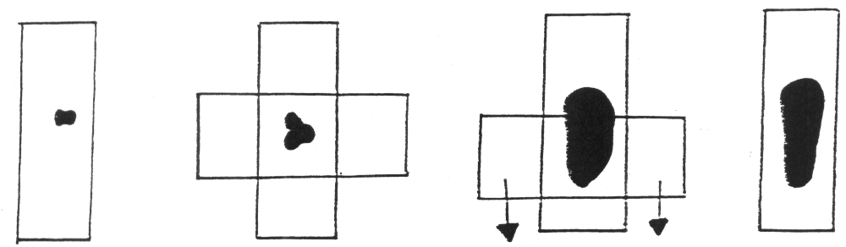

References
Cowell R L, Tyler R D, Diagnostic Cytology of the Dog and Cat (1989). American Veterinary Publications Inc, Goleta, California.

