
IDEXX Laboratories Ltd
Grange House, Sandbeck Way
Wetherby
West Yorkshire LS22 7DN
Tel: UK:+44(0)2037 887508
Eire:+353(0) 156 21211

Fax: +44(0) 1937 544001
E-mail: customersupportuk@idexx.com

FINE NEEDLE ASPIRATION

Indications
This technique is most commonly used to collect cells from:
- Cutaneous and subcutaneous masses and cystic lesions. It may allow differentiation of inflammatory and neoplastic processes. This procedure is of particular use as a screening process and is very helpful in planning the surgical approach, e.g. in the case of a mast cell tumour where the advised surgical margins are greater than would normally be considered.
- Lymph nodes. It is most commonly used in the investigation of lymphadenopathy, particularly to differentiate between hyperplastic reactions and lymphoproliferative disease. If malignancy metastatic to lymph node is suspected, positive cytologic findings may be possible. Negative cytologic findings do not completely rule out metastatic neoplasia and histology may be needed to identify small neoplastic foci that may be missed by FNA.
- Internal organs. The liver or the spleen may yield cells which reflect the pathological process if the changes are diffuse. The sampling of focal lesions requires ultrasound guidance. Significant complications associated with the fine needle biopsy of internal organs are not common, but include internal haemorrhage and the potential seeding of neoplastic cells along needle tracts or throughout the peritoneum.

Equipment and Procedure
- Needle size may vary from 21 to 25 gauge with the finer needles being more appropriate for internal organs or deep masses. Occasionally the use of a larger bore needle is helpful to increase the cellularity, although this can produce excessive iatrogenic blood contamination. The skin should be clipped and prepared and the mass fixed by digital pressure.
- For highly vascular lesions/organs the fine needle puncture non-aspiration technique may be sufficient to minimize blood contamination. However for poorly exfoliating masses (e.g. mesenchymal processes) and in general to increase the cellular yield the aspiration technique may be used. The needle is inserted into the tissue and 2-5 ml of suction applied.
- Whichever the technique, during the sampling the needle should be redirected 3-4 times within the mass/lesion either in a straight line or along a number of different tangents to increase the probability of a representative sample. The amount of material collected may be very small (especially when sampling from solid tissue) and may be contained within the hub of the needle.
- The syringe is then disconnected, filled with air and the contents of the needle hub gently ejected onto a slide.
- Where a lesion has multiple areas of varying appearance, e.g. a solid area and a cystic space, is important that cells are aspirated from each region. Often the examination of cyst fluid alone is unrewarding since the cells within the fluid may not be representative of the underlying cause.
- If fluid is aspirated, this should be transferred in an EDTA tube.
- To preserve the cellular morphology it would be useful to include, when enough fluid has been withdrawn, a second EDTA sample promptly fixed with the addition of at least 1-2 drops of 10% buffered neutral formal saline (as supplied in our histopathology pots) per ml of fluid, and labelled it accordingly. This will be processed separately and stained with a modified Papanicolaou stain, which greatly improves the diagnostic yield.

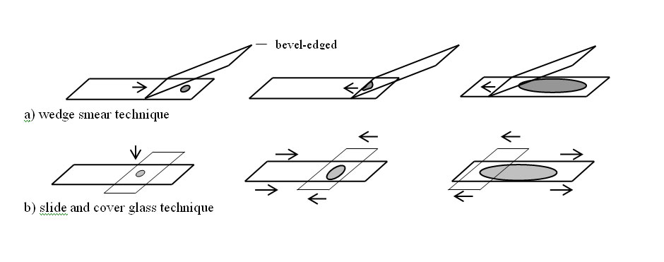
Fig 1:Wedge preparation of slide

A small amount of the sample is placed on one side of a slide. The second slide should have a bevel edge to minimize cellular disruption. It is positioned in the middle of the first slide with an angle of 45 degree (fig. 1a). The angle may be decreased depending on the viscosity of the material. The slides are then gently slid to touch the material so this will spread by capillarity along its edge (fig 1b). The slide is then gently pulled across the other side until the two slides are separated (not pulled) (fig. 1c).
ABC

Smear Making
Smears should be made immediately. The aim of smear-making is to display the cells in a monolayer while causing minimal disruption.
Wedge preparations (push smears, as for blood) are suitable for peripheral blood, non-viscous fluid aspirates, and the sediment of body cavity fluids, prostatic washings and urine. See figure 1 below.
Squash preparations may be preferred for viscous fluid (e.g. synovial fluid, BAL/tracheal washes) and bone marrow aspirates. See figure 2 below.
To ensure the whole specimen is entirely stained the material should occupy the central part of the slides, leaving a free margin (about 0.5 cm) on both the sides of the slide (see picture).
Rapid drying of the smear is important to maintain the cellular morphology. The use of a hairdryer (cool/warm air directed onto the back of the glass from a distance of at least 15 cm) will facilitate this. When slides are submitted to the laboratory a detailed description of the size and the appearance of the mass contributes to achieving a meaningful cytological interpretation.
If concurrent formalin-fixed biopsies are submitted, these should be packaged separately from the cytologic specimen and cytologic smears to avoid exposure to formalin fumes that may result in poor cytologic staining.
A B C D

0.5 cm
0.5 cm
A small amount of the sample is placed on one slide and a second slide placed on top. The second slide may be perpendicular or parallel to the first. The material will spread between the two slides (Figure 2a). If necessary, very gentle pressure may be used to facilitate spreading (fig. 2b) and the top slide is gently pulled across the bottom until the two slides are separated (fig. 2c). The slides should slide apart, and should not be lifted away from each other (fig. 2d).

Fig 2:Squash preparation of slide

